Department of Physics Publishes in Classical and Quantum Gravity
Published on September 22, 2025
Department of Physics
The Research and Postgraduate Centre congratulates undergraduate students Toh Yu Xuan, Chin Yun Ten, Ethan Wu Quanrun, and their advisor Dr. Lim Yen Kheng from the Department of Physics for the recent article published in Classical and Quantum Gravity, a SCI Q1 Journal in theoretical gravitational physics with the latest impact factor of 3.7.
The paper entitled "Properties of the Magnetic Universe with Positive Cosmological Constant" aims to extract physical and geometric information from an exact solution known as the Melvin universe. This is a solution in Einstein-Maxwell gravity which describes a cylindrically-symmetric configuration of magnetic fields held together under its own gravity.
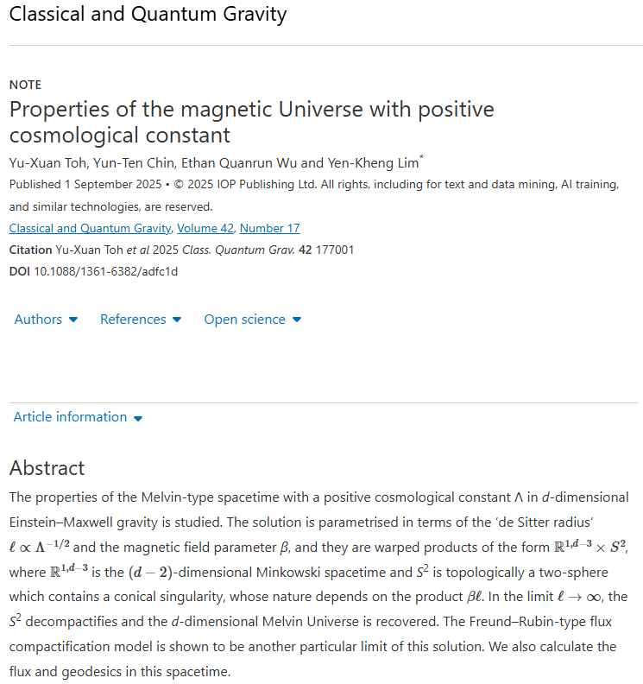
According to Einstein's theory of Relativity, energy and mass are equivalent. Therefore the energy carried by a sufficiently strong magnetic field will start to gravitate. Hence a configuration of strong magnetic field will curve spacetime itself.
In Einstein's theory with zero cosmological constant, such solutions were discovered and rediscovered by several authors throughout the 50s and 60s. Today it is often referred to as the Melvin universe or Melvin spacetime. Recent developments in physics suggests that it is necessary to include a cosmological constant into Einstein’s equation.
In this study, the authors provided a new derivation of the Melvin universe which includes a cosmological constant. The team found that the spacetime with positive cosmological constant has significant differences from its zero- and negative-cosmological constant counterparts. First is that the positive cosmological constant induces a two-dimensional compactification. In short, this means there is an upper limit in a solenoid cross section before the space curves in and closes on itself. If we consider the full closed space, the geometry is found to carry a conical singularity – that is, the sharp corners in the figure below.
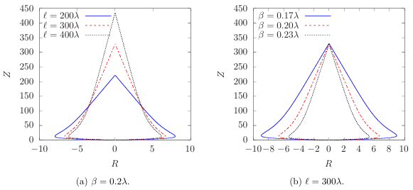
Embedding diagram depicting the shape of the compactification.
With this notion of compactification, the authors found a relation to the Melvin solution with a model of Kaluza-Klein compactification by Freund and Rubin. This connects two different subfields of physics, one is classical relativity with electromagnetism, while the other is theories of higher-dimensional gravity, which is important in braneworlds and quantum gravity.
Besides the geometry, the authors also studied the flux distribution in this spacetime. Unlike everyday solenoids, the distribution of magnetic fields is non-uniform due to the spacetime curvature and the cosmological constant. The results are in line with previous literature showing that a negative cosmological constant serves as a confining force to the flux.
The article can be accessed at https://iopscience.iop.org/article/10.1088/1361-6382/adfc1d.&nbsp;
The Arxiv preprint can be found at https://arxiv.org/abs/2509.01374
About the author
Dr. Yen-Kheng Lim is an Associate Professor of Physics at Xiamen University Malaysia. He received his PhD in 2015 from the National University of Singapore, where he also worked for several years as an instructor. His research interests include black holes, general relativity and gravitational systems in the context of holography and quantum gravity.

